Assessment journal - Brennan Giles

Week 2

21% clay, 40% sand, 39% silt. Triangle lists this as a “Loam”.

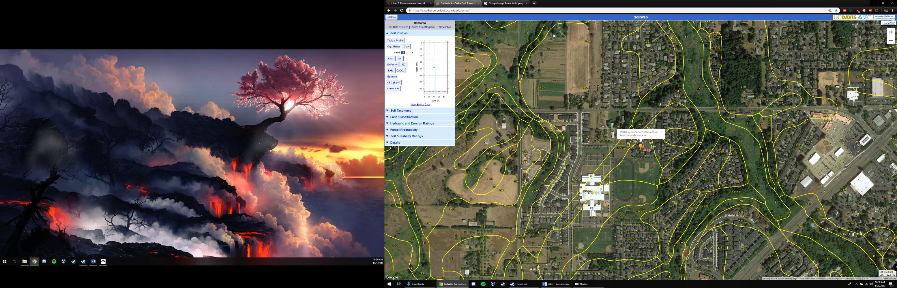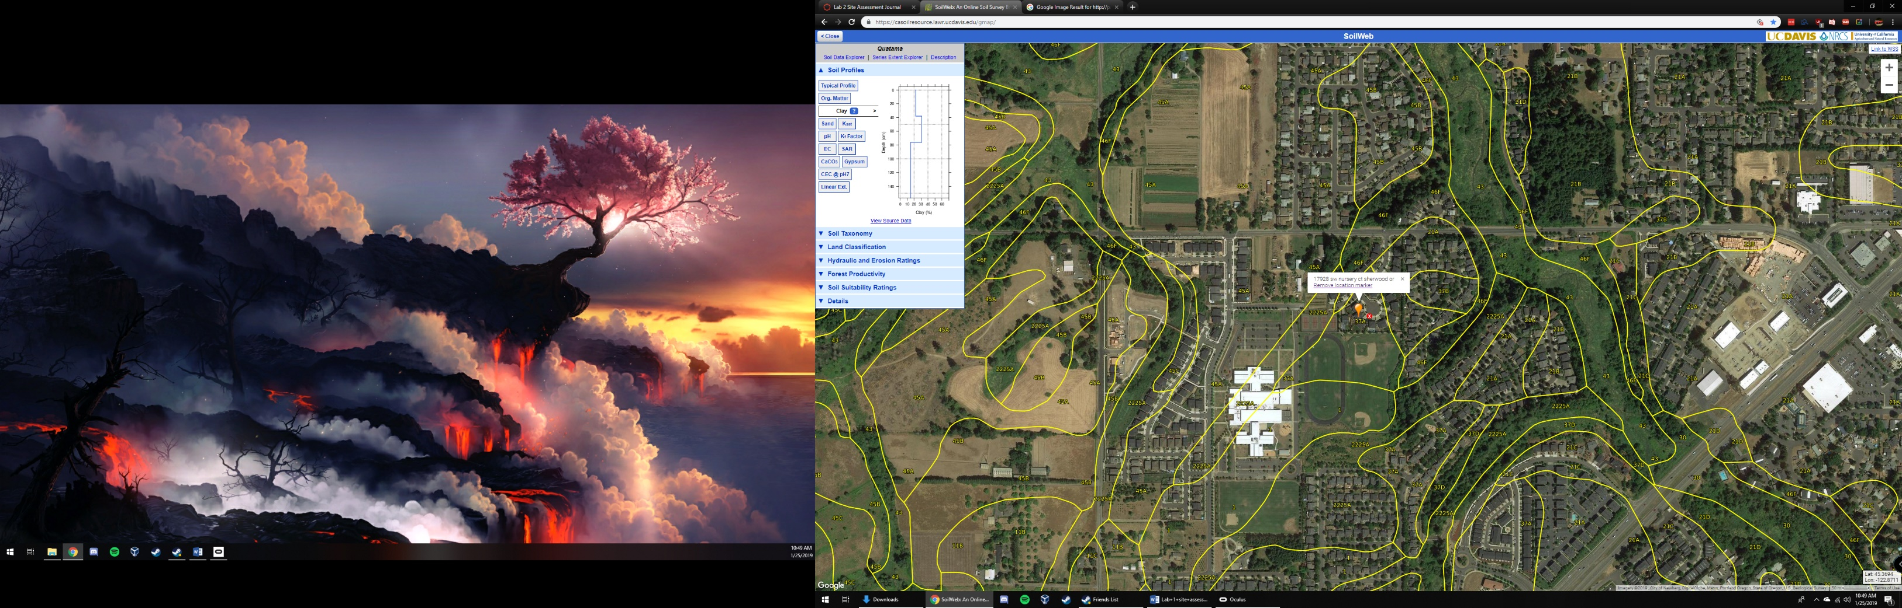I believe the porosity will be just enough for excess water to drain properly however it will be good at retaining water. Loam soil is excellent for farming and thus this property fits that narrative. I think the porosity will be “medium” in that it has almost a fifty fifty split between sand and silt/clay, thus it will sit somewhere in the middle of the charts for that category. When I discovered the soil was a loam I thought it made perfect sense based on my assertions made last week and my own personal memories. This soil is clearly good for growing plants and allows life to flourish within.

Week 1

The significance of this site to me is that this is where my family lives and has lived while I’ve been away at college. Being able to drive home after a term at Corvallis to this place always fills me with joy.

What I remember about the soil is that it is very fertile with a lot of organic matter. This may not make sense but it is some of the “healthiest” soil I know of. It is dark brown and almost entirely soil with only a sparse amount of small rocks inside.

The dominant soil series is the “Quatama Series”.

The typical pedon structure is “Quatama loam, cultivated”. At the top it is loamy, brown, moist with moderate fine and very fine subangular blocky structure. It is moderately acid and tends to have fine roots embedded within it. I’ve never tasted the soil outside my house so I didn’t know it was acidic, but other than that I think I had it spot on from memory. For some context, this area was historically extremely fertile and used as a farming location in the past.

